**In class Exercise – 4/11/2019 – Due on or before Sunday 4/16 by midnight**

**Objective: All function types**

|  |
| --- |
| **Important instructions:**   * *All programs must include comments at the top of your program: your name,* the class name (CSIT 575)*, program name and* ***the program description (purpose of the program).*** * *Copy and paste your* ***program code*** *and* ***output*** *in Part B of each program. Note: Use snipping tool to snip the output.* * *Once it is done, save and submit this word file via Canvas.* |

**1. FavoriteCourse.cpp**

Write a program that asks the user to enter his/her name, favorite course, and the number of credit hours he/she is taking. The program will have the following function prototypes:

* void Header(); //writes header of the program (type 1)
* string AskName(); //asks and returns name of the user (type 3)
* string AskFavCourse(string name); // asks the user to enter his/her favorite course. The function is passed the user’s name and it returns a string. (type 4)
* int HowManyHours(string name, string course); // asks and returns the total number of credit hours he/she is taking this semester. To personalize the question, the user’s name and favorite course must pass to this function. (type 4)
* void Write(string name, string course, int hours);// Pass the name, favorite course and credit hours to the **Write** function, which writes these pieces of data to the screen. (type 2)

All functions are called from **main(). The main function includes a “do again” loop**

**Sample run:**

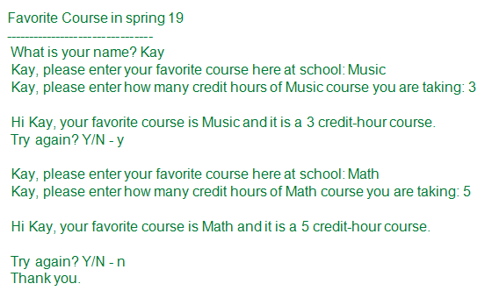

**Part B: Copy and paste your program (source) code and the outputs after this line**

**+++++++++++++++++++++++++++++++++++++++++++++++++**